PYTHON ACTIVITY-BASED LEARNING
Complete Record of 10 Programs
Includes aim, objectives, algorithm, pseudocode, flowchart, source code and sample output for each program.
Note: The sample outputs are generated from the supplied programs using representative inputs. Console preview images are included separately; they are not genuine screenshots captured from PyCharm.

Program 1: Water Tank Level Monitoring
Aim
Water Tank Level Monitoring
Objective
Monitor water in a tank for three days, keep the level within 0 and 1000 units, and stop when it reaches 800 units.

Algorithm
- Start; Set capacity=1000, water=500, threshold=800, days=3
- Repeat for each day from 1 to 3
- Input inflow and outflow
- Update water = water + inflow - outflow
- If water > capacity, display overflow and set water=capacity
- If water < 0, display shortage and set water=0
- Display day and water level
- If water >= threshold, display threshold reached and stop loop
- After loop, display final water level; End

Flowchart
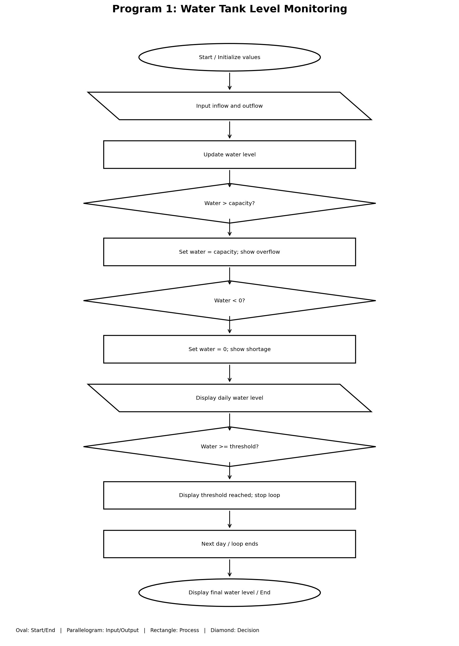

Python Source Code
capacity = 1000 water = 500 threshold = 800 days = 3
for day in range(1, days + 1):
inflow = int(input("Enter inflow: ")) outflow = int(input("Enter outflow: ")) water = water + inflow - outflow
if water > capacity: print("Overflow!") water = capacity
if water < 0: print("Water shortage!") water = 0
print("Day", day, "Water level:", water)
if water >= threshold:
print("Threshold reached on day", day) break
print("Final water level:", water)

Sample Input
100
50
200
20
100
30

Sample Output
Enter inflow: 100
Enter outflow: 50
Day 1 Water level: 550
Enter inflow: 200
Enter outflow: 20
Day 2 Water level: 730
Enter inflow: 100
Enter outflow: 30
Day 3 Water level: 800
Threshold reached on day 3
Final water level: 800

Program 2: Shopping Budget Management
Aim
Shopping Budget Management

Objective
Calculate discounted product costs, compare the total with a budget of Rs. 1000, and reduce quantities until the total is within budget.

Algorithm
- Start; Set budget=1000 and total=0; store product names, prices and quantities
- For each of the three products, calculate price × quantity
- If quantity is at least 2, apply 10% discount
- Display product cost and add it to total
- Display total cost
- If total exceeds budget, display budget exceeded
- For each product, while quantity > 0 and total > budget, subtract one unit price and reduce quantity8. Display final total and remaining budget; End

Flowchart
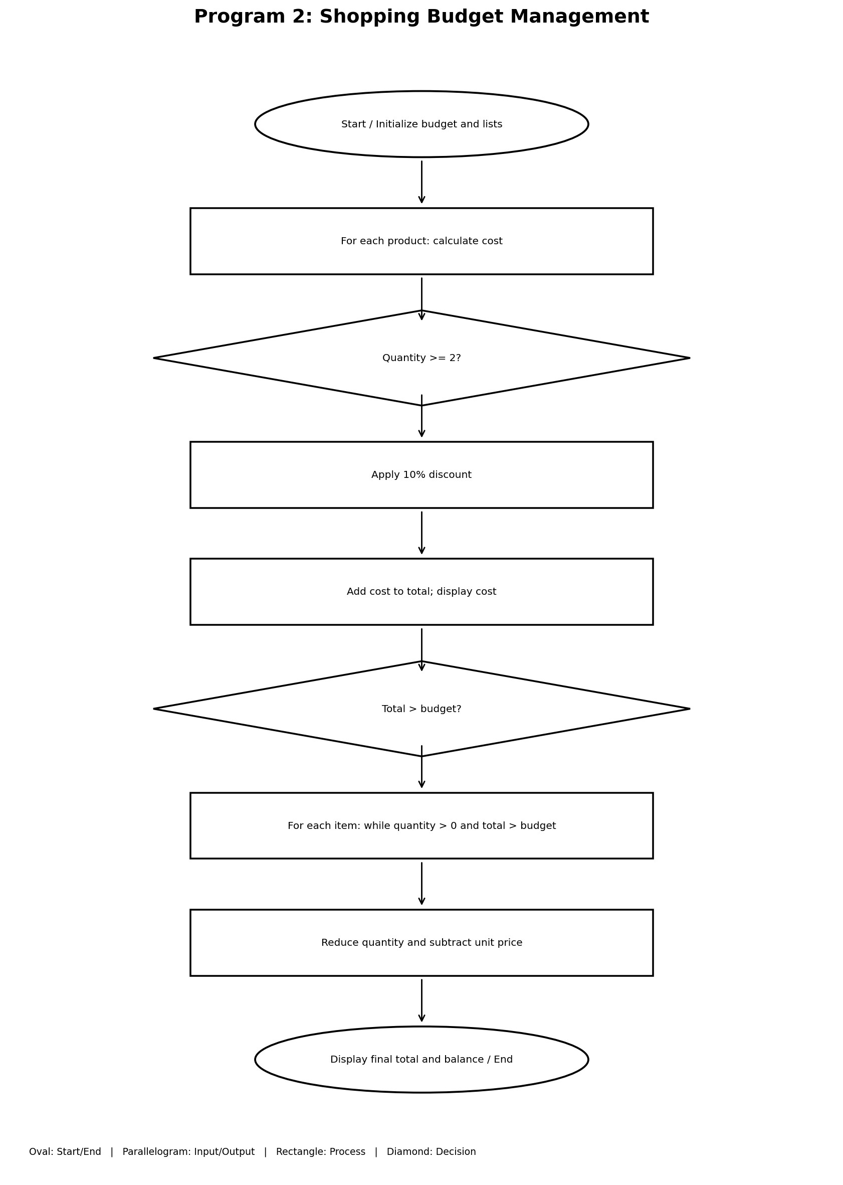

Python Source Code
budget = 1000 total = 0 products = ["Book", "Pen", "Bag"] prices = [300, 50, 600] quantities = [2, 3, 1]
for i in range(3):
cost = prices[i] * quantities[i] if quantities[i] >= 2: cost = cost * 0.9 print(products[i], "Cost:", cost) total = total + cost
print("Total cost:", total)
if total > budget:
print("Budget exceeded!") for i in range(3): while quantities[i] > 0 and total > budget: total = total - prices[i] quantities[i] = quantities[i] - 1 print("Reduce quantity of", products[i])
print("Final total:", total) print("Remaining budget:", budget - total)
Sample Input
No keyboard input (fixed sample data).

Sample Output
Book Cost: 540.0
Pen Cost: 135.0
Bag Cost: 600
Total cost: 1275.0 Budget exceeded!
Reduce quantity of Book
Final total: 975.0
Remaining budget: 25.0

Program 3: Weekly Appliance Electricity Consumption
Aim
Weekly Appliance Electricity Consumption

Objective
Calculate weekly consumption for each appliance, compare it with a 20-unit limit, and calculate the combined consumption for each day.

Algorithm
- Start; Store appliance names, seven-day consumption data and limit=20
- For each appliance, calculate sum of its seven daily values
- Display weekly consumption
- If weekly total > 20, display limit warning
- For each day from 1 to 7, set daily_total=0
- Add that day's consumption for each of the three appliances
- Display daily total; End

Flowchart
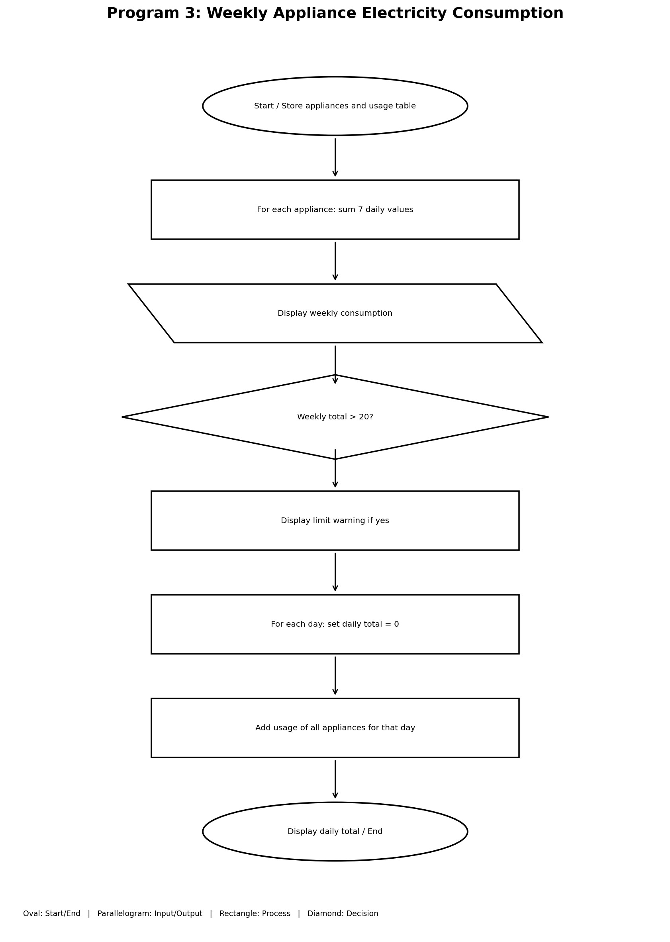

Python Source Code
appliances = ["Fan", "TV", "Fridge"] consumption = [ [2, 3, 2, 3, 2, 3, 2],
[1, 2, 1, 2, 1, 2, 1],
[4, 4, 4, 4, 4, 4, 4] ] limit = 20 for i in range(3):
total = sum(consumption[i]) print(appliances[i], "weekly consumption:", total, "units") if total > limit:
print("Consumption exceeds limit!")
for day in range(7): daily_total = 0 for i in range(3):
daily_total += consumption[i][day] print("Day", day + 1, "total:", daily_total, "units")
Sample Input
No keyboard input (fixed sample data).

Sample Output
Fan weekly consumption: 17 units
TV weekly consumption: 10 units
Fridge weekly consumption: 28 units Consumption exceeds limit!
Day 1 total: 7 units
Day 2 total: 9 units
Day 3 total: 7 units
Day 4 total: 9 units
Day 5 total: 7 units
Day 6 total: 9 units
Day 7 total: 7 units

Program 4: Bus Passenger Count and Capacity Check
Aim
Bus Passenger Count and Capacity Check

Objective
Track passengers boarding and alighting at four stops, prevent a negative passenger count, and report when the bus exceeds its capacity of 50.

Algorithm
- Start; Set capacity=50, passengers=0, stops=4
- Repeat for stops 1 through 4
- Input boarding and alighting passenger counts
- Update passengers = passengers + boarding - alighting
- If passengers < 0, reset passengers to 0
- Display stop number and passenger count
- If passengers > 50, display capacity exceeded
- After four stops, display final passenger count; End

Flowchart
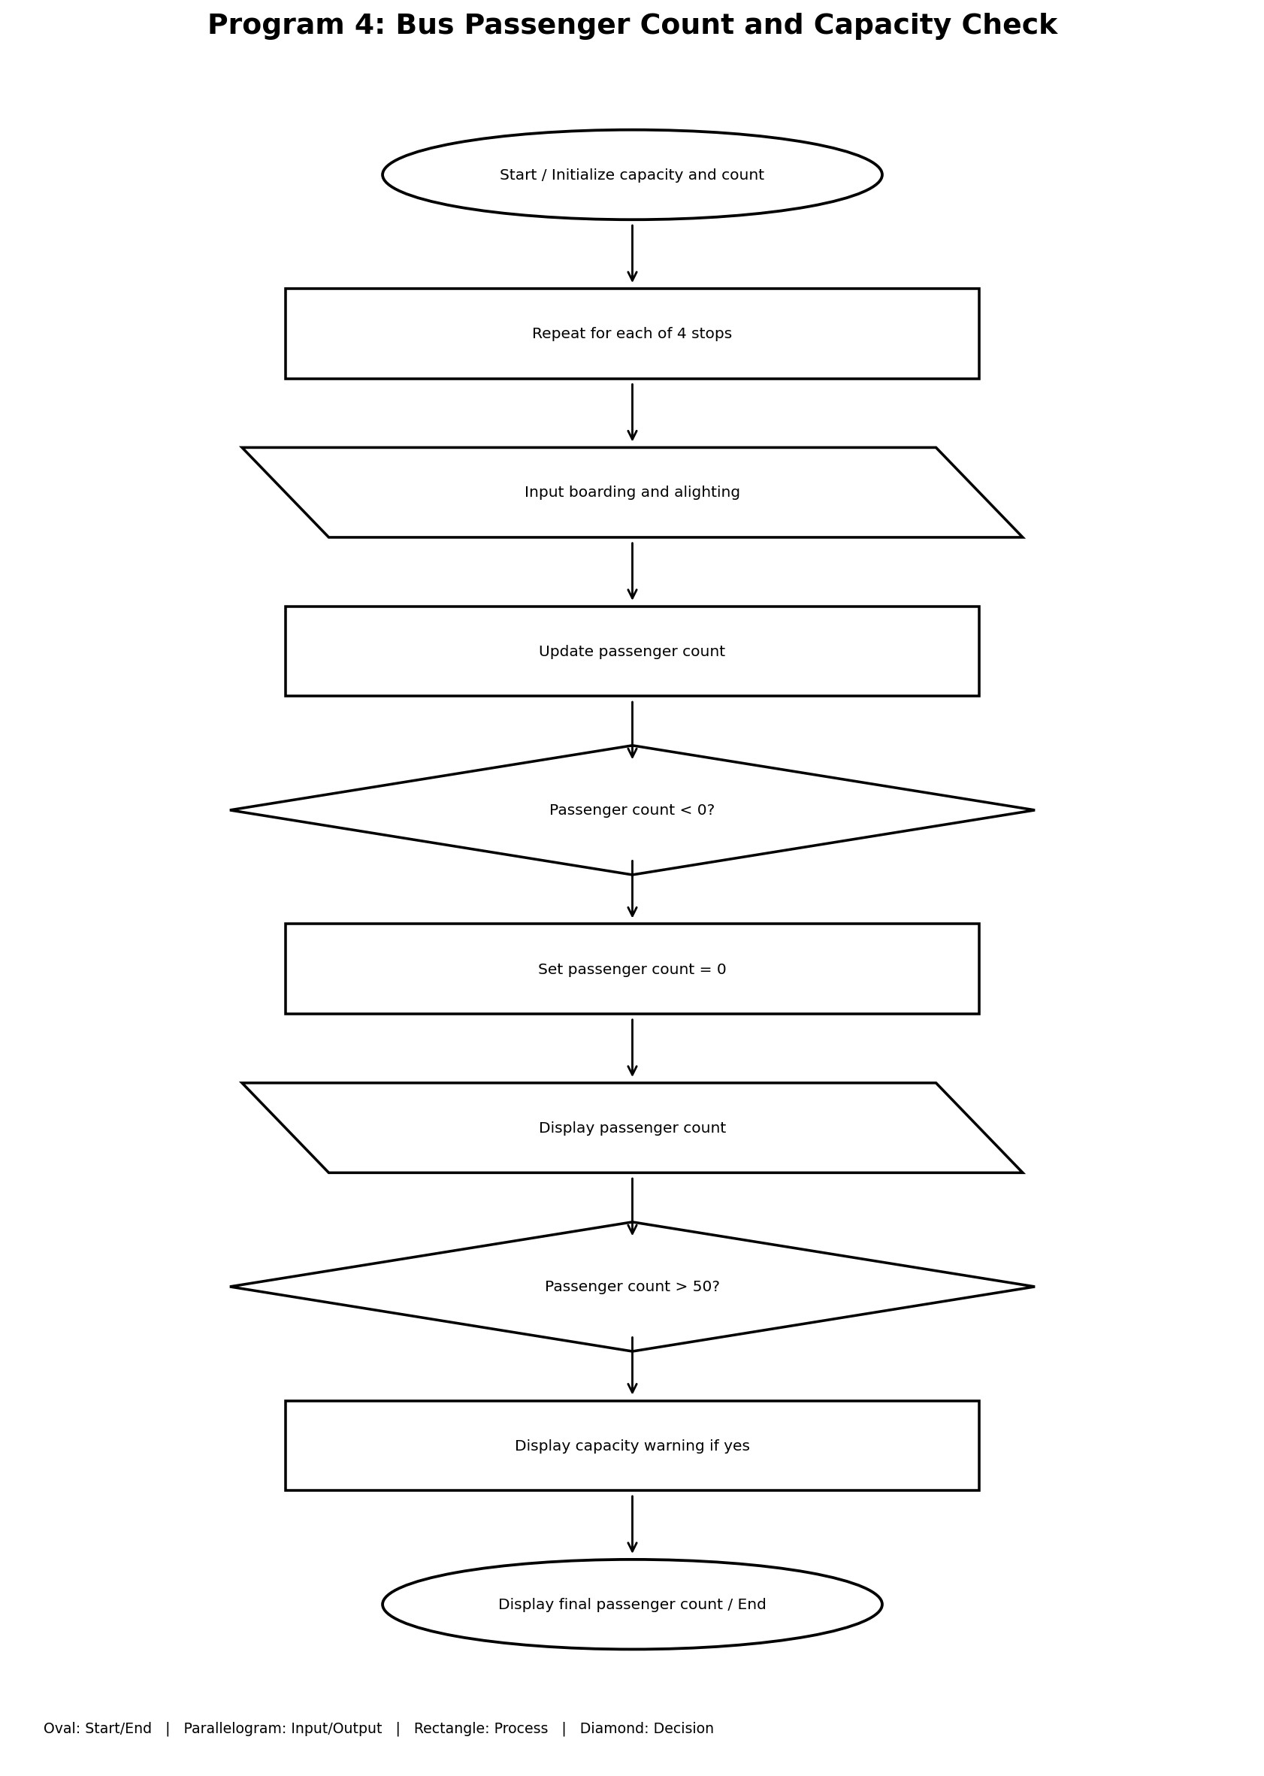

Python Source Code
capacity = 50 passengers = 0 stops = 4
for i in range(1, stops + 1):
boarding = int(input("Enter boarding passengers: ")) alighting = int(input("Enter alighting passengers: ")) passengers = passengers + boarding - alighting
if passengers < 0: passengers = 0 print("Stop", i, "Passengers:", passengers) if passengers > capacity: print("Capacity exceeded!")
print("Final passengers:", passengers)

Sample Input
20
5
15
3
25
10
5
2

Sample Output
Enter boarding passengers: 20
Enter alighting passengers: 5
Stop 1 Passengers: 15
Enter boarding passengers: 15
Enter alighting passengers: 3
Stop 2 Passengers: 27
Enter boarding passengers: 25
Enter alighting passengers: 10
Stop 3 Passengers: 42
Enter boarding passengers: 5
Enter alighting passengers: 2
Stop 4 Passengers: 45
Final passengers: 45

Program 5: Classroom Seating Arrangement Validation
Aim
Classroom Seating Arrangement Validation
Objective
Validate a seating matrix by checking reserved seats, empty seats, invalid roll numbers, and duplicate roll numbers.

Algorithm
- Start; Create seating matrix, reserved-seat list, valid-roll list and empty rolls list
- Set row index i=0; repeat through every row
- Set column index j=0; repeat through every seat in the row
- Read roll number at position (i,j)
- If position is reserved, check whether value is -1; otherwise report reserved-seat error
- Else if roll=0, report empty seat
- Else if roll is not in valid list, report invalid roll
- Else if roll already exists in rolls, report duplicate
- Otherwise append roll to rolls
- Continue until all seats are checked; display completion; End

Flowchart
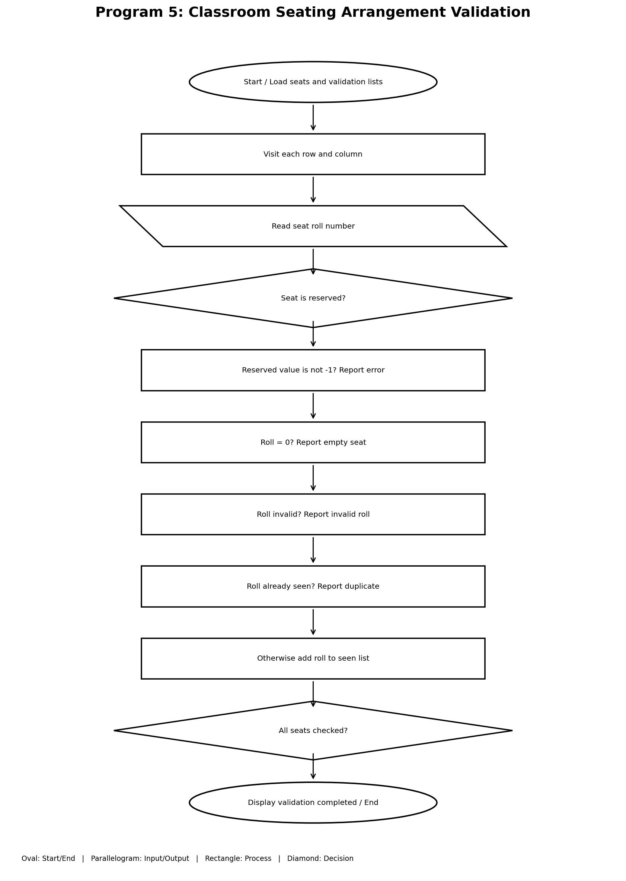

Python Source Code
seats = [ [101, 102, 103],
[104, 0, 106],
[107, 102, -1] ] reserved = [(1, 2)] valid_rolls = [101, 102, 103, 104, 105, 106, 107, 108] rolls = []
for i in range(len(seats)): for j in range(len(seats[i])): roll = seats[i][j] if (i, j) in reserved: if roll != -1:
print("Reserved seat error:", i, j) elif roll == 0:
print("Empty seat:", i, j) elif roll not in valid_rolls:
print("Invalid roll number:", roll) elif roll in rolls:
print("Duplicate roll number:", roll) else: rolls.append(roll)
print("Seating validation completed.")
Sample Input
No keyboard input (fixed sample data).

Sample Output
Reserved seat error: 1 2
Empty seat: 1 1
Duplicate roll number: 102 Seating validation completed.

Program 6: Student Scholarship Eligibility and Ranking
Aim
Student Scholarship Eligibility and Ranking

Objective
Select students who satisfy the academic, attendance, and family-income conditions, then rank eligible students by aggregate marks and attendance.

Algorithm
- Start; Store student records; create empty eligible list
- For each student, read aggregate, subject marks, attendance and income
- Check aggregate >=80, both subject marks >=60, attendance >=75 and income <=10000
- If all conditions are true, add student to eligible list
- Sort eligible students by aggregate and then attendance in descending order
- Set rank=1; display each eligible student's rank, name, marks and attendance7. Increase rank after each student; End

Flowchart
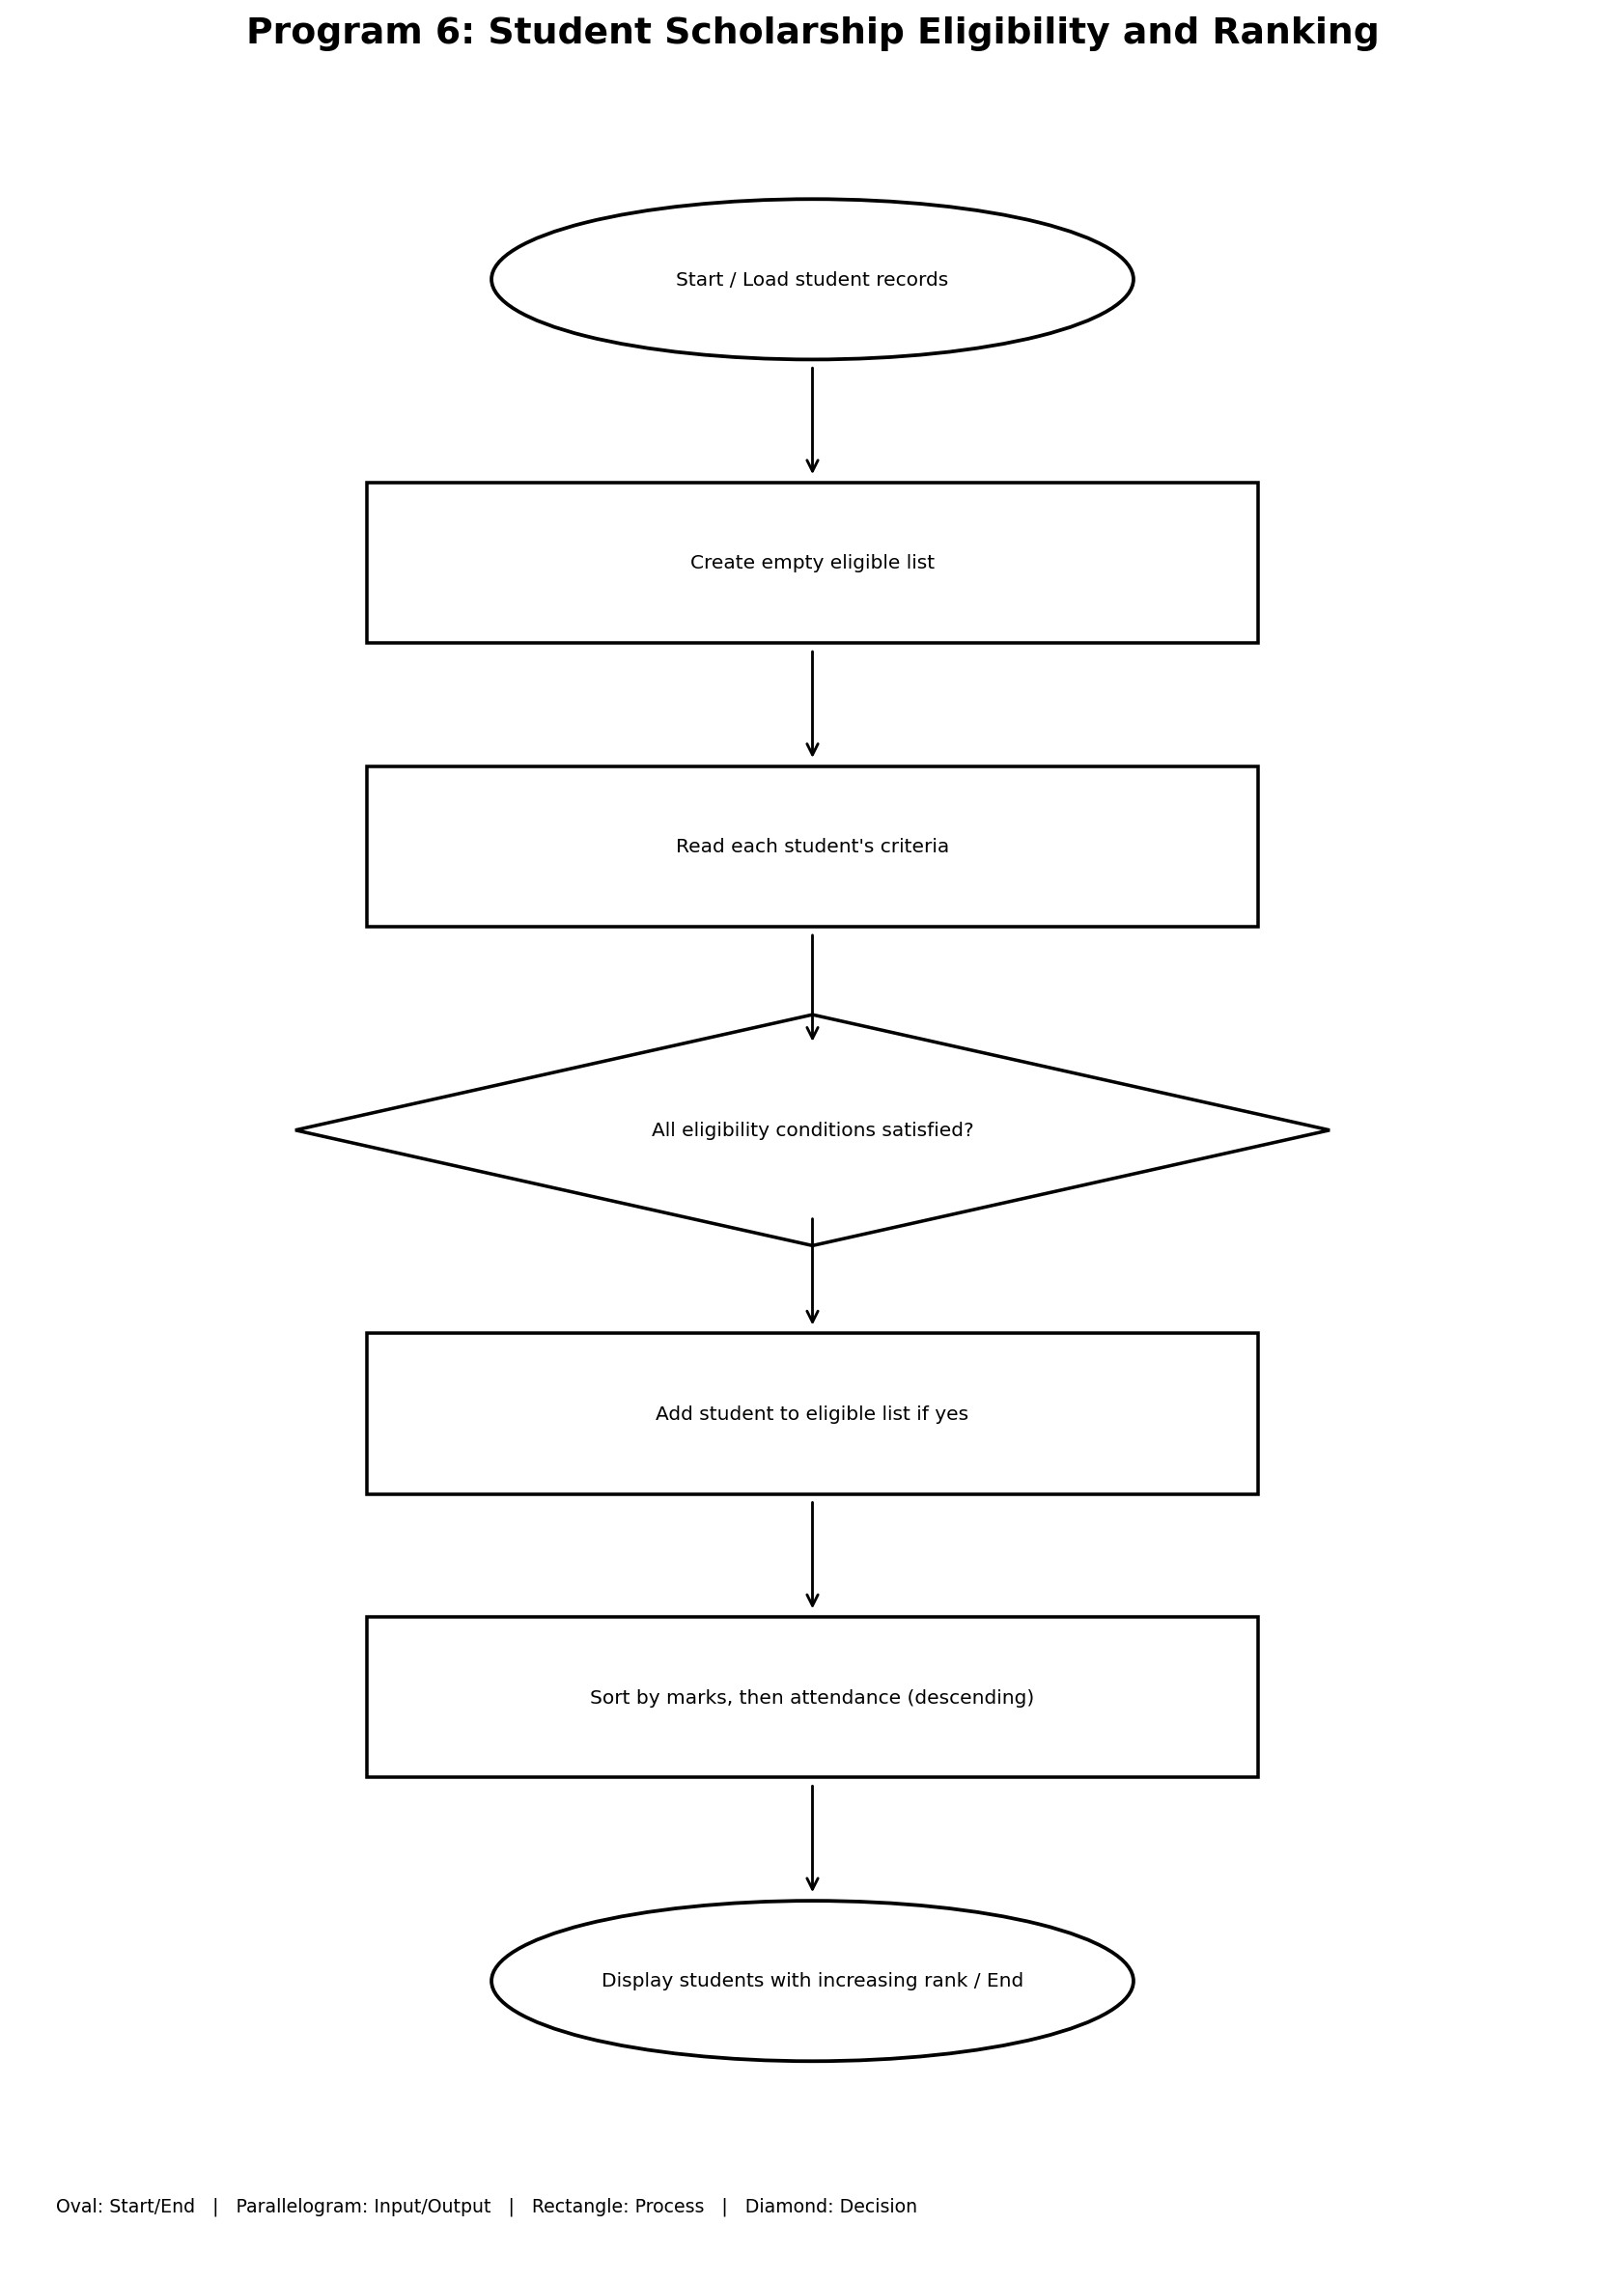

Python Source Code
students = [ ["Ravi", 85, 75, 80, 90, 12000],
["Raju", 90, 80, 85, 95, 10000],
["Sita", 78, 70, 75, 80, 8000],
["Kiran", 90, 80, 85, 95, 9000] ] eligible = [] for s in students:
name = s[0] aggregate = s[1] subject1 = s[2] subject2 = s[3] attendance = s[4] income = s[5] if (aggregate >= 80 and subject1 >= 60 and subject2 >= 60 and attendance >= 75 and income <= 10000): eligible.append(s)
eligible.sort(key=lambda s: (s[1], s[4]), reverse=True) print("Eligible Students:") rank = 1 for s in eligible:
print("Rank:", rank, "Name:", s[0], "Marks:", s[1], "Attendance:", s[4]) rank += 1
Sample Input
No keyboard input (fixed sample data).

Sample Output
Eligible Students:
Rank: 1 Name: Raju Marks: 90 Attendance: 95
Rank: 2 Name: Kiran Marks: 90 Attendance: 95

Program 7: Employee Salary Statement
Aim
Employee Salary Statement

Objective
Accept an employee's salary components, calculate gross salary, apply a deduction rate based on gross salary, and display net salary.

Algorithm
- Start; Input employee name, basic salary, allowances, overtime and incentives
- Calculate gross = basic + allowances + overtime + incentives
- If gross <= 20000, deduction = 5% of gross
- Else if gross <= 40000, deduction = 10% of gross
- Otherwise, deduction = 15% of gross
- Calculate net = gross - deduction
- Display all salary details and net salary; End

Flowchart
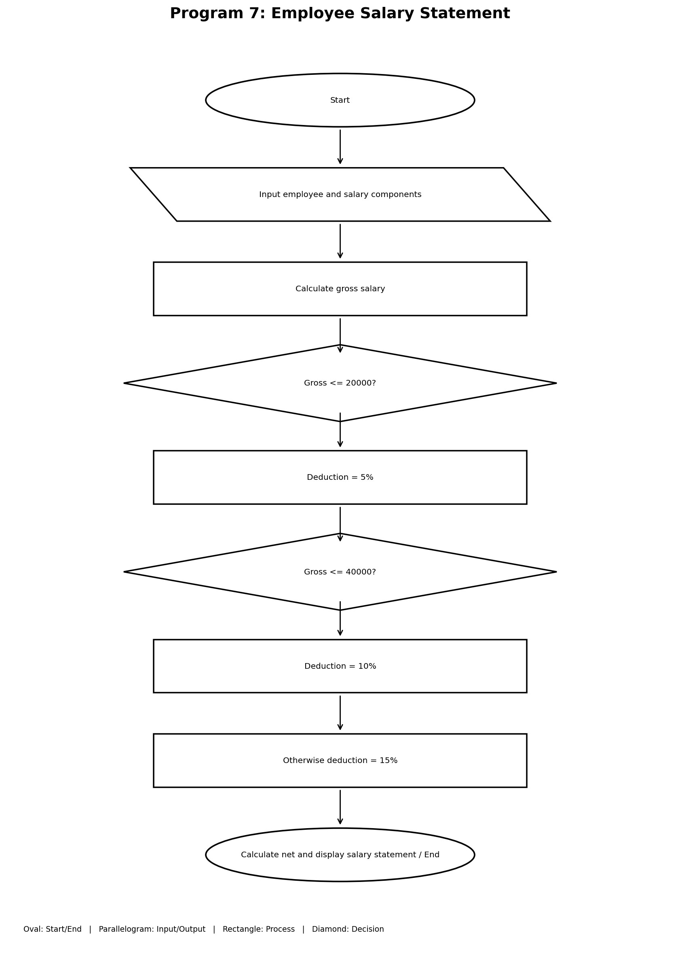

Python Source Code
name = input("Enter employee name: ") basic = float(input("Enter basic salary: ")) allowances = float(input("Enter allowances: ")) overtime = float(input("Enter overtime pay: ")) incentives = float(input("Enter incentives: "))
gross = basic + allowances + overtime + incentives if gross <= 20000:
deduction = gross * 0.05 elif gross <= 40000: deduction = gross * 0.10 else: deduction = gross * 0.15
net = gross - deduction
print("\n--- Salary Statement ---") print("Employee Name:", name) print("Basic Salary:", basic) print("Allowances:", allowances) print("Overtime Pay:", overtime) print("Incentives:", incentives) print("Gross Salary:", gross) print("Deduction:", deduction) print("Net Salary:", net)

Sample Input
Karthik
25000
3000
2000
1000

Sample Output
Enter employee name: Karthik
Enter basic salary: 25000
Enter allowances: 3000
Enter overtime pay: 2000
Enter incentives: 1000
--- Salary Statement ---
Employee Name: Karthik
Basic Salary: 25000.0
Allowances: 3000.0
Overtime Pay: 2000.0
Incentives: 1000.0
Gross Salary: 31000.0
Deduction: 3100.0
Net Salary: 27900.0

Program 8: Campus Event Financial Planning
Aim
Campus Event Financial Planning

Objective
Calculate the total event cost, subtract sponsorship, estimate the minimum number of fee-paying students, and check whether actual contributions cover the budget.

Algorithm
- Start; Input venue, equipment, catering, transport and certificate costs
- Input sponsorship and registration fee per student
- Calculate total event cost
- Calculate remaining amount = total - sponsorship; if negative, set it to zero
- If fee > 0, calculate ceiling(remaining / fee) as minimum students
- Input actual participants and calculate participant contributions
- If contributions + sponsorship < total, display shortfall; otherwise display budget covered8. If fee <= 0, display fee validation message; End

Flowchart
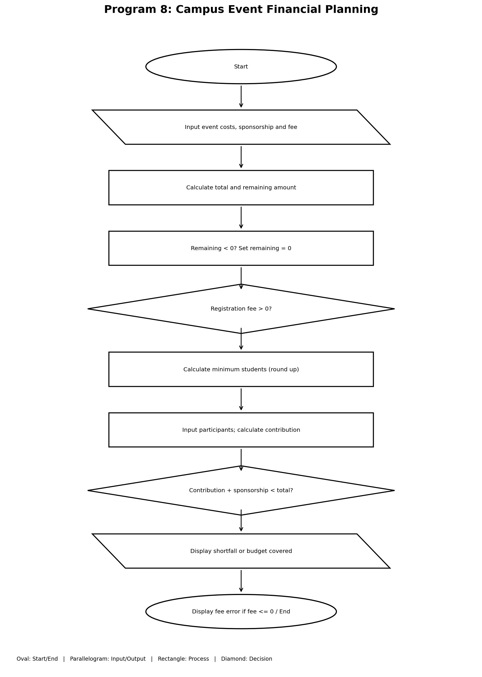

Python Source Code
venue = float(input("Enter venue cost: ")) equipment = float(input("Enter equipment cost: ")) catering = float(input("Enter catering cost: ")) transport = float(input("Enter transport cost: ")) certificates = float(input("Enter certificate cost: ")) sponsorship = float(input("Enter sponsorship amount: ")) fee = float(input("Enter registration fee per student: ")) total = venue + equipment + catering + transport + certificates print("\nTotal Event Cost:", total) remaining = total - sponsorship if remaining < 0: remaining = 0 print("Amount needed after sponsorship:", remaining)
if fee > 0:
students = int(remaining / fee) if students * fee < remaining:
students += 1 print("Minimum students needed:", students) participants = int(input("Enter actual participants: ")) contribution = participants * fee print("Participant Contributions:", contribution) if contribution + sponsorship < total:
print("Sponsorship shortfall:", total - contribution - sponsorship) else:
print("Event budget covered!") else: print("Registration fee must be greater than zero.")

Sample Input
10000
5000
12000
3000
1000
10000
100
250

Sample Output
Enter venue cost: 10000
Enter equipment cost: 5000
Enter catering cost: 12000
Enter transport cost: 3000
Enter certificate cost: 1000
Enter sponsorship amount: 10000
Enter registration fee per student: 100
Total Event Cost: 31000.0
Amount needed after sponsorship: 21000.0
Minimum students needed: 210
Enter actual participants: 250
Participant Contributions: 25000.0 Event budget covered!

Program 9: Bank Deposit and Withdrawal Transactions
Aim
Bank Deposit and Withdrawal Transactions

Objective
Process a specified number of deposits or withdrawals, validate transaction amounts and withdrawal limits, and display the final balance and successful transaction count.

Algorithm
- Start; Initialize balance=5000, withdrawal limit=2000, transactions=0
- Input number of transactions
- Repeat for each transaction; display deposit and withdraw choices
- Input choice and amount
- If amount <= 0, display invalid amount
- Else if choice=1, add amount to balance and increment successful transactions
- Else if choice=2, check withdrawal limit, then available balance; subtract only if both checks pass
- For any other choice, display invalid choice
- After loop, display successful transaction count and final balance; EndFlowchart
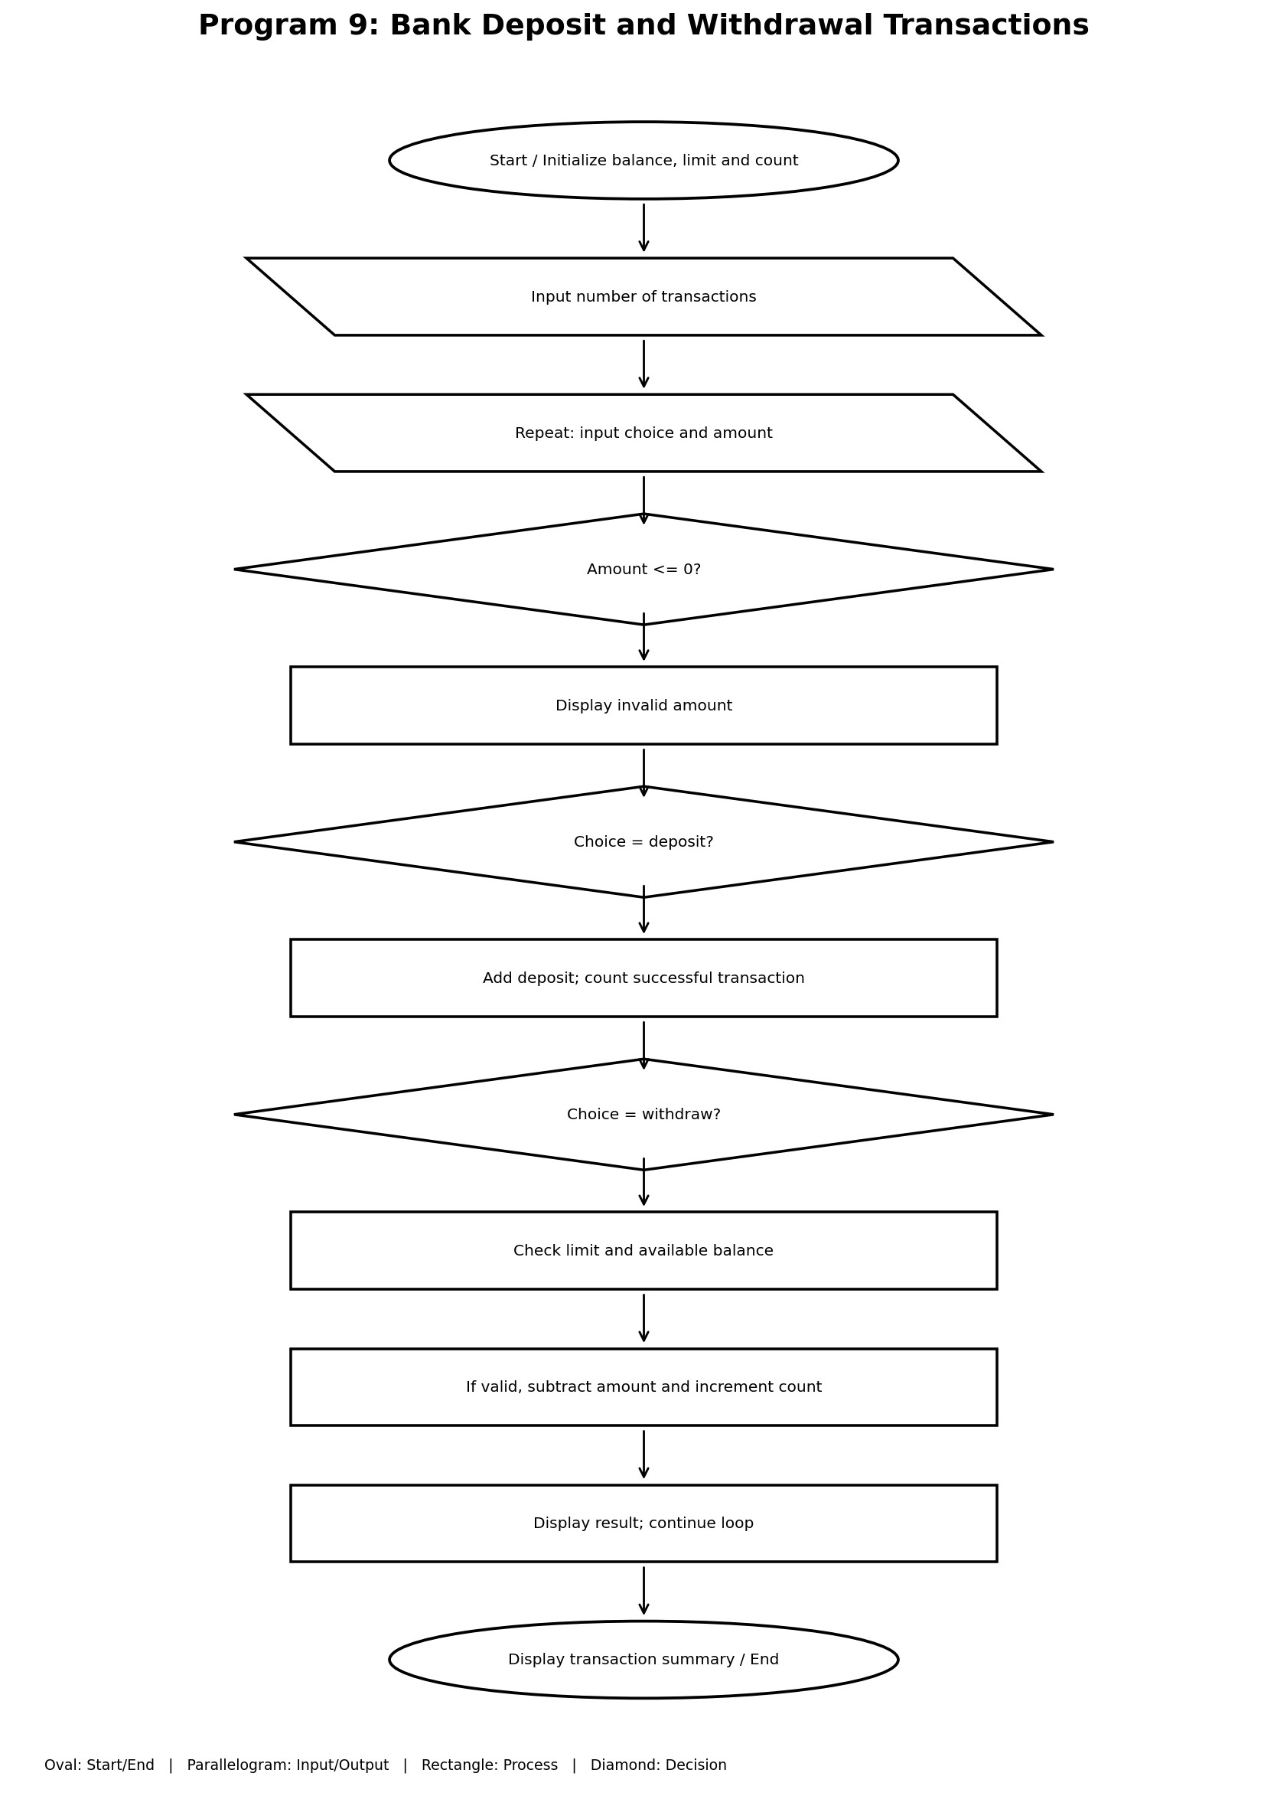

Python Source Code
balance = 5000 limit = 2000 transactions = 0 n = int(input("Enter number of transactions: "))
for i in range(n): print("1. Deposit") print("2. Withdraw") choice = int(input("Enter your choice: ")) amount = float(input("Enter amount: "))
if amount <= 0:
print("Invalid amount!") elif choice == 1: balance += amount transactions += 1 print("Deposit successful!") elif choice == 2: if amount > limit:
print("Withdrawal limit exceeded!") elif amount > balance:
print("Insufficient balance!") else:
balance -= amount transactions += 1 print("Withdrawal successful!") else: print("Invalid choice!")
print("\n--- Transaction Summary ---") print("Total transactions:", transactions) print("Final balance: Rs.", balance)

Sample Input
3
1
1000
2
1500
2
2500

Sample Output
Enter number of transactions: 3
- Deposit
- Withdraw
Enter your choice: 1
Enter amount: 1000 Deposit successful!
- Deposit
- Withdraw
Enter your choice: 2
Enter amount: 1500 Withdrawal successful!
- Deposit
- Withdraw
Enter your choice: 2
Enter amount: 2500 Withdrawal limit exceeded!
--- Transaction Summary ---
Total transactions: 2
Final balance: Rs. 4500.0

Program 10: Water Tank Level Monitoring for Five Days
Aim
Water Tank Level Monitoring for Five Days

Objective
Monitor tank water for up to five days, correct overflow or negative levels, and stop early when the water level reaches 800 units.

Algorithm
- Start; Set capacity=1000, water=500, threshold=800, days=5
- Repeat for each day from 1 to 5
- Input inflow and outflow; update water level
- If water exceeds 1000, display overflow and set it to 1000
- If water is below 0, display shortage and set it to 0
- Display current day and water level
- If water >= 800, display threshold reached and exit loop
- After loop, display final water level; End

Flowchart
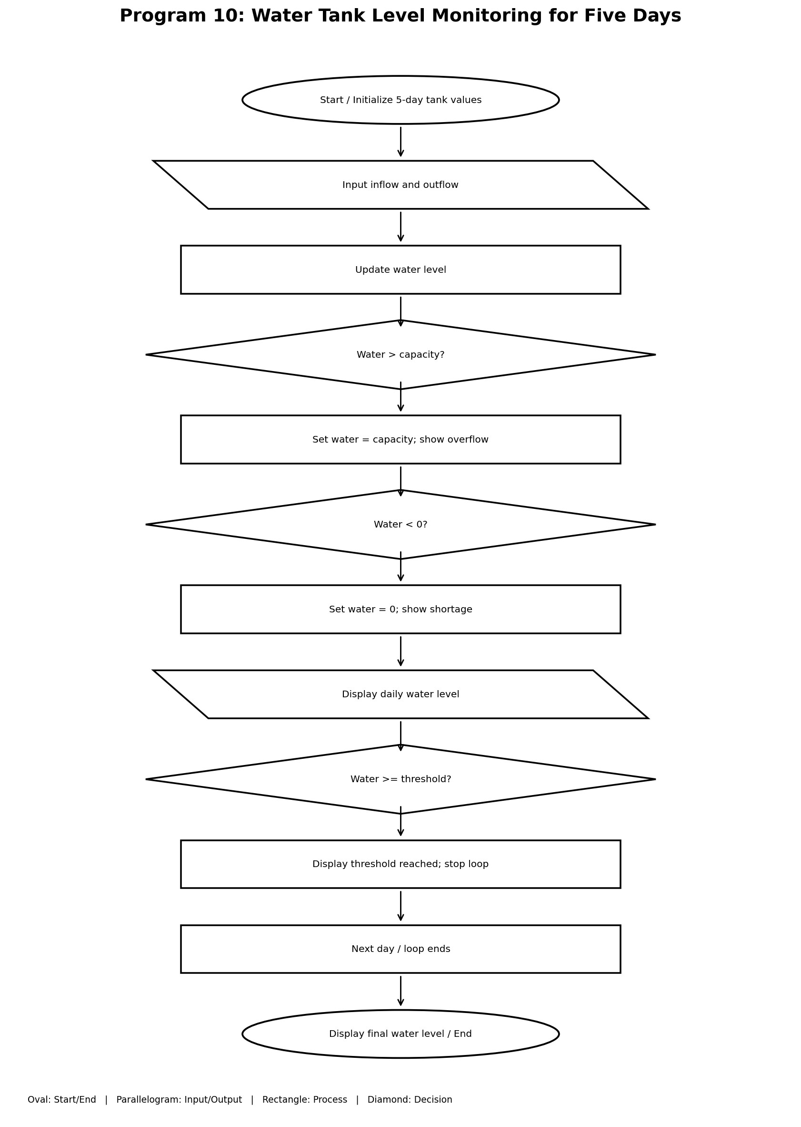

Python Source Code
capacity = 1000 water = 500 threshold = 800 days = 5
for day in range(1, days + 1):
inflow = int(input("Enter inflow: ")) outflow = int(input("Enter outflow: ")) water = water + inflow - outflow
if water > capacity: print("Overflow!") water = capacity if water < 0: print("Water shortage!") water = 0
print("Day", day, "Water level:", water) if water >= threshold:
print("Threshold reached on day", day) break
print("Final water level:", water)

Sample Input
100
50
200
20
100
30

Sample Output
Enter inflow: 100
Enter outflow: 50
Day 1 Water level: 550
Enter inflow: 200
Enter outflow: 20
Day 2 Water level: 730
Enter inflow: 100
Enter outflow: 30
Day 3 Water level: 800
Threshold reached on day 3
Final water level: 800

